V.S.A.BENAVENTE MIDDLE SCHOOL
LIBRARY MEDIA CENTER
3 YEAR ACTION PLAN
SY 2013-2016
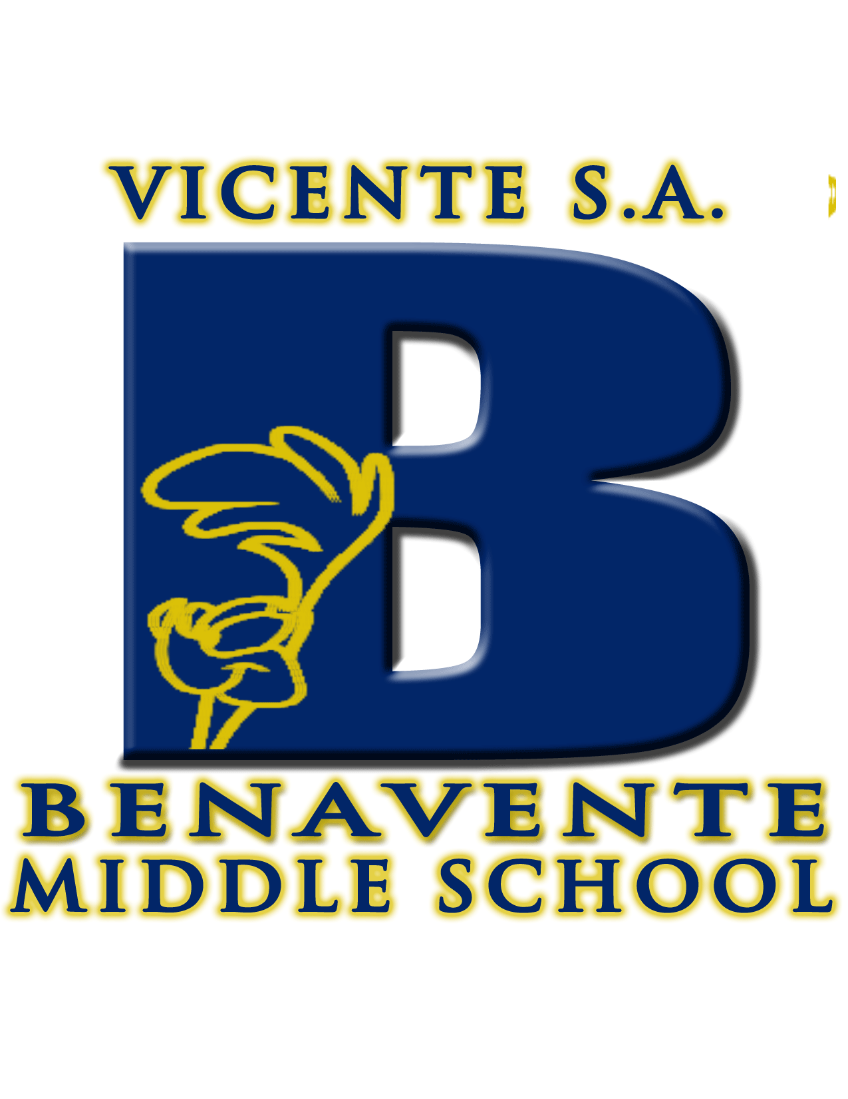

Vicente S.A. Benavente Middle School
LIBRARY MEDIA CENTER 3 YR PLAN
School Year 2013-14, 2014-15, 2015-2016
Louise K. Togawa, Certified Librarian

GUAM DEPARTMENT OF EDUCATION LIBRARY MEDIA CENTER MISSION:

The Mission of the Library Media Program of the Guam Public School System is to provide information to students and staff in a variety of formats, teach the skills to use it, and instill the desire to read and explore as lifelong learners.

I. Library Media Program Goals

Quality library programs serve to improve literacy skills and academic achievement of students by providing students with increased access to up-to-date school library materials, a well-equipped technological library media center, and well-trained, professionally certified school library media specialists. (NCLB)

II. General Objectives

Benavente Middle School Library Media Center will…….

- Ensure that all patrons have ready access to a library-automated system consisting of various library materials, equipment, and technology tools to succeed academically and socially;
- Conduct collaborative lesson planning with the teachers to achieve the skills outlined in the American Association of School Librarians (AASL) Standards for the 21st Century Learner;
- Ensure that patrons have access to an inviting, well equipped, and conducive environment that meets the learning, technological, and social needs of a 21st Century Learner;
- Support the GDOE Curriculum and Standards, AASL Library Standards, SAT 10 Skills, BMS Smart Goals, and Common Core Standards;
- Promote and foster the love for reading, so that students become lifelong learners and independent users of information and technology.

III. PROGRAM COMPONENTS

- CURRICULUM

NEEDS ADDRESS: The Guam Department of Education (GDOE) has recently adopted the Common Core Curriculum that most states are already implementing already. Thus making this our top focus and priority in all the Guam Public Schools. Therefore, librarians must be ready, willing, and able to support this new educational movement of “Common Core”. However, many teachers have not been trained yet nor do they have the knowledge to. As “Resource People” or the “GO TO” experts we help to provide the resource materials or technological access necessary to achieve successful teacher and student outcomes.

PROGRAM GOALS: To collaborate with teachers on the development of engaging lesson plans that promotes information literacy skills and all other GDOE program standards that make students academically successful and lifelong learners.
To establish a resource section in the library that supports the Common Core Standards for teachers to access in our library.

OBJECTIVES:
  - By June 2014, 2015, and 2016, BMS library will provide collaborative lesson plans taught throughout the year that support the curriculum goals and standards of the library and the Guam Department of Education.
  - By June 2014, BMS library will establish a teacher media center well equipped with Common Core resources.

Action Step | Responsible Party | Resources | Timeline | Indicators of Completion
1.1  Library Lesson Planning | Certified Librarian AND  Classroom Teacher | AASL Standards for the 21st Century Learner; Common Core Standards,  SMART Goals for Reading, Language Arts, and Math; Guam DOE Curriculum and Content Standards; BMS Collaboration Lesson Plan Form, and on-line resources | On-Going  SY 2013-2014  SY 2014-2015  SY 2015-2016 | Completed lesson plans for 6th, 7th, and 8th graders in ALL subject areas.
1.2 Teaching library skills/ lessons to achieve student knowledge of skills listed in objectives. | Certified Librarian and  Classroom Teachers | Lesson plan materials as appropriate to current lesson. | On-Going  SY 2013-2014  SY 2014-2015  SY 2015-2016 | Grades on worksheets and writings, observations, and rubric evaluations of student skills.
1.3 Procurement of lesson plan supplies | Certified Librarian and MUNIS Approvers | Access to library funds, quotes from vendors, and web based procurement system.  Annual Budget: $200.00 | Ongoing as allowed by funding availability | Supplies in place and available for use.
1.4 Procurement of Common Core Teacher Resources | Certified Librarian, Library Committee and MUNIS Approvers | Solicit teacher input and Library Committee recommendations  Quotes from vendors  Annual Budget: $1000.00 | On-Going  SY 2013-2014  SY 2014-2015  SY 2015-2016 | Vendor Invoice and copy of Purchase Order

CONCLUSION: The Library Media Center’s impact, dedication, and commitment to student learning are our utmost concern. Teaching the information literacy skills from the Standards for the 21st Century Learner will help acquire the dexterities to prepare students to succeed academically and socially in a rapidly changing world of technology. By collaborating with other teachers we are actually demonstrating to teaching our students the benefits of team work and interacting with others can lead to positive end results.

II. TECHNOLOGY

NEEDS ADDRESSED: The library has improved drastically in the area of technology due to the explosion of the Information Age. The world of information is at the tips of our fingertips. Our next goal for SY 2013-2014, is to bring iPads into the library to enhance literacy through technology. The library will also offer training to teachers who wish to learn new web-sites and operate our technology tools. BMS Library Media Center will be the lead middle school library in the Guam Public School that will model the Virtual library concept.

PROGRAM GOAL: To improve student academic and technology skills through the use of technology and by providing in-service technology training to teachers in need.
To provide students with iPads and various educational Apps that will improve, promote and impact literacy in all subject content areas.
To introduce and conduct eBooks lessons that support Common Core and Curriculum goals using an interactive white board.

OBJECTIVES:
2.1 By Sept 2013, the librarian will conduct mini training demonstrations on how to use the Elmo projector and Brain Pop Educational Software.
2.2 By June 2014, 2015, 2016, students will access iPads with Educational Apps account to reinforce skills and concepts in the various subject areas.
2.3 By June 2014, 2015, 2016, students will be exposed to eBooks using an interactive white board, iPads, and computers.

ACTION STEPS: | RESPONSIBLE  PARTY | RESOURCES | TIMELINE | INDICATORS OF COMPLETION
2.1  Conduct Training Session for Elmo Projector/Brain Pop Software | Certified Librarian AND Administrator | Elmo, Multi-media Projector AND Computers with internet access. | September 2013 | Sign-In Attendance Roster  Technology Training Survey
2.2 Procurement of (5) five iPads per year | Certified Librarian AND MUNIS Approvers | Access to Library Funds, Vendor Price Quotes, and Annual Budget of $2,025.00 per year | SY 2013-2014  SY 2014-2015  SY 2015-2016 | Check-Out History Report by Library World, lesson plans, and observation of use. PO & Vendor Invoice
2.3 Procurement of Mobile Interactive White Boards  (1) one per school year | Certified Librarian AND MUNIS Approvers | Access to Library Funds, Vendor Price Quote, and Annual Budget of: $3000.00 | SY 2013-2014  SY 2014-2015  SY 2015-2016 | PO & Vendor Invoice,  Check-Out History Report,

CONCLUSION: Students and teachers will be exposed to innovative technological tools that the library provides in order to support the curriculum and academic achievements. Our students will be equipped with the knowledge and skills to become functional and productive citizens as well as lifelong learners. In the near future, BMS library media center will be transformed into a modern day virtual library for patrons to enjoy at any time of the day.

III. AUTOMATION SYSTEM

NEEDS ADDRESSED: Due to the beginning of this school year, our entire computers that support our Library World software were stolen along with our back-up external drives. Unfortunately, we lost our entire collection. As a result, we are still working on downloading MARC records for books in our collection. We recently received a computer system, which will contain our library automation collection and OPAC (On-line Public Access Collection) information for patron use.

PROGRAM GOAL: To complete downloading and importing MARC records in our Library World automation system and be able to access the information for searching for book and eBook titles as well as checking in and out materials and equipment.
To develop a web based on-line public access to our collection for school community to browse through and check-out/in our eBooks collection independently.

OBJECTIVES:

3.1 By August 2013, the library will complete importing MARC records into Library World and be fully operational in time for the beginning of this school year 2013-2014.
3.2 By Jan 2014, 2015, 2016, the library will purchase an annual web based online resource to Library World for school library patrons to access 24/7.

ACTION STEPS: | RESPONSIBLE  PARTY | RESOURCES | TIMELINE | INDICATORS OF COMPLETION
3.1 Exporting/Importing MARC records for library automation and actual use of automation system | Certified Librarian | Computers with internet, books and web site. | August 2013 | MARC records in our library automation and the utilization of the automation system.
3.2 Procurement of Library World web based collection | Certified Librarian AND MUNIS Approvers | Vendor Price Quote and Access to library funds  Annual Budget: $450.00 | On-going  SY 2013-2014  SY 2014-2015  SY 2015-2016 | PO and Vendor Invoice  Availability of web based resource

CONCLUSION: Students need to be independent learners, information seekers, and technology literate in order to obtain the information and resources for academic and social needs. Library resources should be available for students to access anytime—anywhere.

IV. COLLECTION BUILDING AND MAINTENANCE

NEEDS ADDRESSED: Our library recently completed the weeding out of our outdated collection. The library continues to purchase printed books for those students whom may not have access to technology or simple prefer holding an actual book instead of an electronic device. The library plans to move toward eBooks as early as next school year. Many teachers utilize our DVD collection to reinforce their lessons and have taken the initiative to recommend titles that support the curriculum. Magazines are a real hit with our school community. I noticed that this is one way to attract patrons interested in visiting the library.

PROGRAM GOAL: To acquire books, magazines, DVDs and eBooks to our collection for the purpose of building a strong, high-quality library media collection suited to our school community and supporting our school’s Curriculum, Common Core, Standards, as well as for fostering the love of reading.
To establish a section in the library devoted to building our Common Core resources that supports Reading, Writing, and Math literacy.

OBJECTIVES:

  - By June 2014, 2015, 2016, the library will expand our DVD, book, and magazine collections that will support the curriculum, standards, Common Core, and students’ interests.
  - By June 2014, 2015, 2016, the library will establish purchasing eBooks that will provide teachers with 21st Century resources.
  - By June 2014,2015,2016, the library will purchase the latest and newest technology tools to enhance student learning.

ACTION STEPS: | RESPONSIBLE  PARTY | RESOURCES | TIMELINE | INDICATORS OF COMPLETION
4.1 Procurement of newspaper and magazine subscriptions | Certified Librarian, Library Committee, and MUNIS Approvers | Price Quotation from EBSCO and Magazine.com Subscription; Access to Library Funds  Annual Budget: $250.00 | SY 2013-2014  SY2014-2015  SY 2015-2016 | PO and Vendor Invoice  Availability of magazines
4.2 Procurement of School Library Journal as required by law | Certified Librarian AND MUNIS Approvers | Vendor Price Quotation  Access to Library Funds  Annual Budget: $125.00 | SY 2013-2014  SY2014-2015  SY 2015-2016 | PO and Availability of magazine subscriptions
4.3 Procurement of HW Wilson Subscriptions as required by law | Certified Librarian AND MUNIS Approvers | Vendor Price Quotation  Access to Library Funds  Annual Budget: $225.00 | SY 2013-2014  SY2014-2015  SY 2015-2016 | PO and Availability of magazine subscriptions
4.4 Procurement of Educational DVDs | Certified Librarian, Library Committee and MUNIS Approvers | Vendor Price Quotation  Access to Library Funds  Annual Budget: $600.00 | SY 2013-2014  SY2014-2015  SY 2015-2016 | PO, Availability of DVDs, and data of check-outs
4.5 Procurement of new printed books (Fiction) | Certified Librarian, Library Committee, and MUNIS Approvers | Vendor Price Quotation  Access to Library Funds  Annual Budget: $4,000.00 | SY 2013-2014  SY2014-2015  SY 2015-2016 | PO, Availability of Fiction books, and data of check-outs
4.6 Procurement of eBooks | Certified Librarian, Library Committee, and MUNIS Approvers | Vendor Price Quotation  Access to Library Funds  Annual Budget: $5,000.00 | SY 2013-2014  SY2014-2015  SY 2015-2016 | PO, Availability of ebooks, and data of check-outs
4.8 Procurement of NEW technology tools | Certified Librarian, Library Committee and MUNIS Approvers | Vendor Price Quotation  Access to Library Funds  Annual Budget: $3,000.00 | SY 2013-2014  SY2014-2015  SY 2015-2016 | PO and availability of item
4.9 Procurement of Graphic Novels | Certified Librarian, Library Committee and MUNIS Approvers | Vendor Price Quotation  Access to Library Funds  Annual Budget: $700.00 | SY 2013-2014  SY2014-2015  SY 2015-2016 | PO, Availability of Graphic Novels, and data of check-outs
4.10 Procurement of Non-Fiction Section Lacking Books (000-299, 400-499, and 800-899) | Certified Librarian, Library Committee and MUNIS Approvers | Vendor Price Quotation  Access to Library Funds  Annual Budget: $700.00 | SY 2013-2014  SY2014-2015  SY 2015-2016 | PO, Availability of Non-Fiction books, and data of check-outs

CONCLUSION: Building and maintaining a high-quality library collection that is of relevance to our patrons creates a venue where students can research accurate information, read interesting literature, and enhance learning outcomes through reading. Reading literacy is the key to success in a competitive world filled with constant innovative technology. An adequate, modern, conducive, and accessible library media center truly demonstrates our ESLRs of: Value Our Community, Succeed Academically, Adapt to Changing Times, Make Positive Choices, and Strive for a Better Tomorrow.

V. LIBRARY STRUCTURE

NEEDS ADDRESSED: One of the reasons I believe the BMS Library Media Center no longer has major issues is the fact that the incumbent in the librarian position remains the same. Consistency in school personnel, their diligence in accomplishing missions set forth, and support from admin are key to successful outcomes. As a result of no turnover in the library position, our library faces minimal issues and nothing that will not cause the library to shut down or disrupt operations. All the fundraiser efforts have paid off and only now are we reaping the benefits of the hard work.

PROGRAM GOAL: To maintain a clean, attractive, organized and inviting virtual library media center that is well equipped with resources and technology that will motivate our patrons to utilize it to its full potential and take pride in their library.
To create a Teacher Media Center in the library that will invite and encourage our teachers to utilize our facility and resources that will assist teachers in accomplishing their mission.

OBJECTIVES:

5.1 By August 2013, 2014, 2015, the library media center will maintain a clean, organized, and inviting facility for patrons to come and enjoy an atmosphere rich in resources, technology and space for leisure reading.
5.2 By August 2013, the library will create a Teacher Media Center located in our library equipped with the technology and resource tools to help faculty and staff to get the job done.

ACTION STEPS: | RESPONSIBLE  PARTY | RESOURCES | TIMELINE | INDICATORS OF COMPLETION
5.1 Maintain clean and inviting place | Administration Team and Certified Librarian | Cleaning supplies, paint, and personnel | SY 2013-2014  SY2014-2015  SY 2015-2016 | Clean facilities with freshly painted walls
5.2 Create a Teacher Media Center Room in the library. | Administration Team, Library Committee and Certified Librarian | Already purchased tables, multi-media and laptops from FSAIS. | SY 2013-2014  SY2014-2015  SY 2015-2016 | Completion of Teacher Media Center and historical data of teacher usage.

CONCLUSION: The functionality of use in the library media centers facilities send a strong message to both our students and teachers that our library is the hub, lead, and center of support for information literacy and resource accessibility. Adequate functional space that meets the needs of all patrons is the envy of any school library. We are blessed to have a reasonable amount of space that supports our mission and vision of the library. We look forward to improving this area.

VI. SPECIAL PROGRAMS AND OTHER ACTIVITIES

NEEDS ADDRESSED: The upcoming school year of 2013-2014, the librarian would like to be more involved in the schools curriculum planning and initiate reading literacy program.

PROGRAM GOAL: To encourage students to participate in various library activities and events set forth from the American Libraries Association (ALA) by aligning it with our school’s calendar of events scheduled throughout the school year.

OBJECTIVES:
6.1 By August 2013, 2014, 2015, the library will provide students with library activities promoted by the American Libraries Association.
6.2 By August 2013, 2014, 2015, the library will establish a Library Book Club for students interested in reading, sharing, and enjoying the love of reading.
6.3 By Aug 2013, 2014, 2015, the library will promote and encourage reading various books throughout the year.

ACTION STEPS: | RESPONSIBLE  PARTY | RESOURCES | TIMELINE | INDICATORS OF COMPLETION
6.1 Plan a calendar of events for library | Certified Librarian, Library Committee, and Administrators | Calendar of Events for School Year and ALA.org site | SY 2013-2014  SY 2014-2015  SY 2015-2016 | Newsletters, Posting info. On Library Webpage, Facebook, Email Communication, and Bulletin Announcements
6.2 Form a Library Book Club called “Friends of the Library” | Certified Librarian, Club Advisors, and Students | The Club’s By-Laws, advisors, and students | SY 2013-2014  SY 2014-2015  SY 2015-2016 | Book Club in place and Posting of Book Club on library web site.
6.3 Promote various books throughout the year. | Certified Librarian, Club Advisors, and Students | Certified Librarian and Book Club | SY 2013-2014  SY 2014-2015  SY 2015-2016 | Bulletin Board, Book Display, and Library Website

CONCLUSION: Having regular library activities and events throughout the school year promotes the library’s role and dedication in literacy sends a message to our school community that libraries aren’t what they use to be—“a depository of books”, but rather that libraries have changed in the way we service our patrons. We want to make it clear to everyone that libraries are VALUEABLE tool and vital to a school’s success. We need all stake holders to be our voice and advocate to fight to keep our libraries open.

BMS LIBRARY MEDIA CENTER ACTION PLAN

SY 2013-2014 |  | SY 2014-2015 |  | SY 2015-2016
CURRICULUM: |  | CURRICULUM: |  | CURRICULUM:
Lesson Plan Supplies | $200.00 | Lesson Plan Supplies | $200.00 | Lesson Plan Supplies | $200.00
Common Core Teacher Resources | $1000.00 | Common Core Teacher Resources | $1000.00 | Common Core Teacher Resources | $1000.00
TECHNOLOGY: |  | TECHNOLOGY: |  | TECHNOLOGY:
IPADS (5) PER YEAR | $2025.00 | IPADS (5) PER YEAR | $2025.00 | IPADS (5) PER YEAR | $2025.00
Mobile Interactive White Boards (1) | $3000.00 | Mobile Interactive White Boards (1) | $3000.00 | Mobile Interactive White Boards (1) | $3000.00
AUTOMATION: |  | AUTOMATION: |  | AUTOMATION:
Library World Online Support | $450.00 | Library World Online Support | $450.00 | Library World Online Support | $450.00
COLLECTION BUILDING AND MAINTENANCE |  | COLLECTION BUILDING AND MAINTENANCE |  | COLLECTION BUILDING AND MAINTENANCE
HW Wilson Subscriptions | $225.00 | HW Wilson Subscriptions | $225.00 | HW Wilson Subscriptions | $225.00
DVD Collection | $600.00 | DVD Collection | $600.00 | DVD Collection | $600.00
Library Books | $4125.00 | Library Books | $4125.00 | Library Books | $4125.00
eBooks | $5000.00 | eBooks | $5000.00 | eBooks | $5000.00
Other New Technology | $3000.00 | Other New Technology | $3000.00 | Other New Technology | $3000.00
Newspaper/Magazine Subscriptions | $250.00 | Newspaper/Magazine Subscriptions | $250.00 | Newspaper/Magazine Subscriptions | $250.00
School Library Journal | $125.00 | School Library Journal | $125.00 | School Library Journal | $125.00
Graphic Novels and Non Fiction Books | $1400.00 | Graphic Novels and Non-Fiction Books | $1400.00 | Graphic Novels and Non-Fiction Books | $1400.00
TOTAL ESTIMATE | $21,400.00 | TOTAL ESTIMATE | $21,400.00 | TOTAL ESTIMATE | $21,400.00

SUBMITTED BY: _____________________________________________________ DATE: _______________________________
LOUISE K. TOGAWA
CERTIFIED LIBRARIAN
VICENTE S.A. BENAVENTE MIDDLE SCHOOL

APPROVED BY: _________________________________________________________ DATE: _______________________________
DEXTER B. FULLO
PRINCIPAL
VICENTE S.A. BENAVENTE MIDDLE SCHOOL

APPROVED BY: _______________________________________________________ DATE: ________________________________
JOSEPH SANCHEZ
SUPERINTENDENT
CURRICULUM & INSTRUCTION DIVISION
GUAM DEPARTMENT OF EDUCATION

